To Prove :
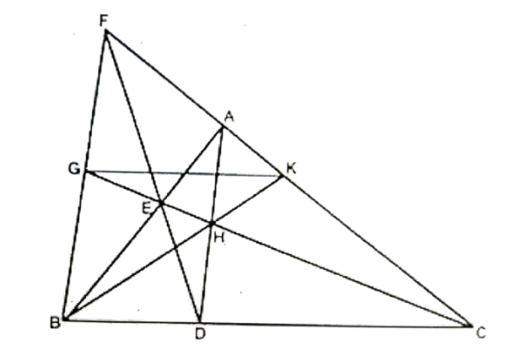
GK $∥$ BC
It is enough to prove $\frac{FG}{GB}=\frac{FK}{KC}$(from converse of BPT)
Proof:
In $∆ FBC;$cevians FD, BA, CG are concurrent at E.
$∴$ $\frac{FG}{GB}×\frac{BD}{DC}×\frac{CA}{AF}=1$
$$⇒\frac{FG}{GB}×\frac{1}{2}×\frac{CA}{AF}=1$$
$⇒\frac{FG}{GB}=\frac{2AF}{AC}$ -----------------------------(1)
In $∆ABC,$ ceivans AD, BK, CF are concurrent at H
$∴$ $\frac{AE}{EB}×\frac{BD}{DC}×\frac{CK}{KA}=1$ [from Ceva's theorem]
$⇒\frac{AE}{EB}×\frac{1}{2}×\frac{CK}{KA}=1$
$⇒\frac{AE}{EB}=\frac{2AK}{CK}$ -------------------------- (2)
In $∆ABC,$ DEF is transversal
$∴$ $\frac{BD}{DC}×\frac{CF}{FA}×\frac{AE}{BE}=1$ (from 'Menaulas Theorem')
$$⇒\frac{1}{2}×\frac{CF}{CA}×\frac{AE}{BE}=1$$
$\frac{AE}{BE}×\frac{2AF}{CF}$ --------------------- (3)
from (2) & (3)
$$\frac{AK}{CK}×\frac{AF}{CF}$$
Adding '1' on both sides
$$⇒\frac{AK}{CK}+1=\frac{AF}{CF}+1$$
$$⇒\frac{AK+CK}{CK}=\frac{AF+CF}{CF}$$
$$⇒\frac{AC}{CK}=\frac{AF+CF}{CF}$$
$$⇒\frac{CF}{CK}=\frac{AF+CF}{AC}$$
subtracting '1' on both sides
$$\frac{CF}{CK}-1=\frac{AF+CF}{AC}-1$$
$\frac{CF-CK}{CK}=\frac{AF+CF-AC}{AC}$
$\frac{FK}{KC}=$ $\frac{AF+CA+AF-AC}{AC}$ [$∵CF=CA+AF]$
$\frac{FK}{KC}=\frac{2AF}{AC}$ ------------------------------(4)
from (1) & (4)
$\frac{FG}{GB}=\frac{FK}{KC}$
R. Hara Gopal
Which implies GK $∥$BC from converse of basic proportionality theorem.
***********

